**UMTS(3G/WCDMA) Architecture**

The UMTS Network architecture has three main entities:

1) Core Network (CN)

2) UMTS Terrestrial Radio Access Network (UTRAN)

3) User Equipment (UE)

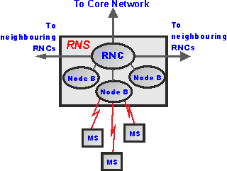

**1.Core Network:**

The core network provides all the central processing and management for the system. It is the equivalent of the GSM Network Switching Subsystem or NSS.

The Core Network is divided in circuit switched and packet switched domains. Some of the circuit switched elements are Mobile services Switching Centre (MSC), Visitor location register (VLR) and Gateway MSC. Packet switched elements are Serving GPRS Support Node (SGSN) and Gateway GPRS Support Node (GGSN). Some network elements, like EIR, HLR, VLR and AUC are shared by both domains.

**2.UMTS terrestrial RAN (UTRAN):**

UTRAN consist of Radio Network Subsystems (RNSs). The RNS has two main elements:

1. Radio Network Controllers (RNC)
2. Node B

**1. Radio network controller (RNC):**

* The RNC is responsible for control of the radio resources in its area. One RNC controls multiple nodes B.
* The RNC in UMTS provides functions equivalent to the Base Station Controller (BSC) functions in GSM/GPRS networks.
* The major difference is that RNCs have more intelligence built-in than their GSM/GPRS counterparts. For example, RNCs can autonomously manage handovers without involving MSCs and SGSNs.

**2.Node B:**

* The Node B is responsible for air-interface processing and some radio-resource management functions.
* The Node B in UMTS networks provides functions equivalent to the base transceiver station (BTS) in GSM/GPRS networks. UMTS operates at higher frequencies than GSM/GPRS and therefore the signal coverage range is less.

****3.User Equipment(UE):****

The MS of GSM is referred as user equipment (UE) in UMTS. It is enabled with an UMTS SIM (USIM).

· International Mobile Subscriber Identity (IMSI)

· Temporary Mobile Subscriber Identity (TMSI)

· Packet Temporary Mobile Subscriber Identity (P-TMSI)

· Temporary Logical Link Identity (TLLI)

· Mobile station ISDN (MSISDN)

· International Mobile Station Equipment Identity (IMEI)

· International Mobile Station Equipment Identity and Software Number (IMEISV)  
  
**UMTS Modes of Operations:**

UMTS mobile station can operate in one of three modes of operation:

· **PS/CS mode of operation:** The MS is attached to both the PS domain and CS domain, and the MS is capable of simultaneously operating PS services and CS services.

· **PS mode of operation:** The MS is attached to the PS domain only and may only operate services of the PS domain. However, this does not prevent CS-like services to be offered over the PS domain (like VoIP).

· **CS mode of operation:** The MS is attached to the CS domain only and may only operate services of the CS domain.

**IMS Architecture**

IMS is a multi-layered architecture.The architecture of an IMS system can be split into a number of main elements:

1. User equipment
2. Access network
3. Core network
4. Application layer

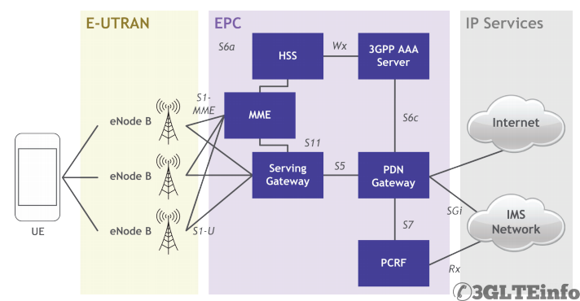

Fig: IMS Architecture with LTE

**1.User Equipment (UE):**

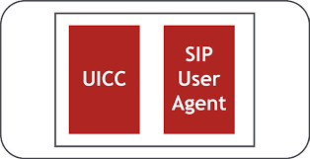

Fig:IMS Capable UE

In IMS, the UE contains a Universal Integrated Circuit Card (UICC) and a Session Initiation Protocol User Agent (SIP UA).

1. **SIP User Agent:**

The SIP UA is the logical terminal of the SIP network and both transmits and receives SIP messaging. It also manages the SIP session from the terminal end.In general, the SIP UA provides typical telephone functionality (e.g. dial, answer, hold, transfer, etc.) via two separate roles:

• UAC (User Agent Client) – Sends SIP requests

• UAS (User Agent Server) – Received requests and sends SIP responses. SIP itself is a protocol (defined in the IETF’s RFC 3261) used for is not used for actual media data transport Transport Protocol (RTP).

1. **Universal Integrated Circuit Card (UICC):**

* Subscriber Identity Module (SIM) – identity information used by a GSM network.
* UMTS Subscriber Identity Module (USIM) – identity information used by a UMTS or LTE network.
* CDMA Subscriber Identity Module (CSIM) or Re-Useable Identification Module (R-UIM) – identity information used by a CDMA network.
* IP Multimedia Services Identity Module (ISIM) – identity information used by the IMS subsystem.

The ISIM contains:

* IP Multimedia Private Identity (IMPI) – Permanently allocated global identity assigned by a user’s home operator. It is analogous to the International Mobile Subscriber Identity (IMSI) used in legacy technologies and is transparent to the subscriber. It includes the home operator’s domain information.
* IP Multimedia Public Identity (IMPU) – Used to request communication with another user, the IMPU can be roughly thought of as analogous to a telephone number.

1. **Access network:**

The IMS access network is made up of those elements that are associated with communication from the core network to the outside world - external networks and users. The IMS network can be accessed through various forms of IP Carrier Access Networks, IP-CAN. The IP-CAN provides the IP connectivity as well as mobility. The IMS terminal sends control plane signalling and media transfer through the IP-CAN to the IMS core network.

1. **IMS Core Network:**

**1.Call Session Control Function (CSCF):**

It controls multimedia sessions and is made up of three separate entities:

**A)Proxy CSCF (P-CSCF):**

The initial point of contact from any SIP User Agent, acting as the UE's proxy for the entire network.

**B)Serving CSCF (S-CSCF):**

A decision point as to whether or not the user’s SIP messages will be forwarded to application servers.

1. **Interrogating CSCF (I-CSCF):**

Initiates the assignment of a user to an S-CSCF (by querying the HSS) during registration, acting as the IMS core's proxy to each individual user.

**2.Home Subscriber Server (HSS):**

The HSS is a database that maintains user profile and location information and is responsible for name/ address resolution. It is also responsible for authentication and authorization, but unlike in legacy technologies, authentication with the radio access network and the core can be different.

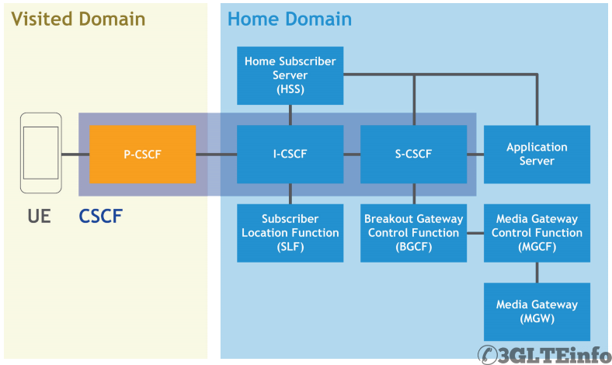

Fig: Interaction between CSCF,HSS and other elements

**3.Subscriber Location Function (SLF):**

The SLF keeps track of multiple HSSes in a home network, and is responsible for assigning one to a user.

**4.Media Gateway Control Function (MGCF):**

The MGCF controls media gateways (MGWs), performs transcoding (converting codecs, for example from EVRC to WB-AMR) and the conversion of media between the Real-time Transport Protocol (RTP) used in IMS and the PulseCoded Modulation (PCM) used by a circuit-switched network.

**5.Breakout Gateway Control Function (BGCF):**

If an MGCF does not include the breakout to a circuit-switched network, that functionality is performed by the BGCF. When the BGCF does control this breakout it does so by selecting an MGCF (either in the same IMS network or another IMS network) or by selecting an MGW (on a non-IMS-based network).

1. **Media server function control (MSCF):**

This manages the use of resources on media servers.

1. **SIP applications server(SIP-AS):**

The SIP-AS is a service execution platform on which one or more services are deployed.

**7.Media Gateways:**

Media Gateway resides at the interface between SIP-based IMS network and traditional PSTN network.

**EPC:**

For VoLTE and IMS prospective two nodes are important in the Evolved Packet Core.

**1.Public Data Network(PDN) Gateway:**

PDN Gateway allocates IP addresses to UEs. PDN-GW is also the point of communication between EUTRA and non-3GPP services like the internet.When IMS is available, there can be more that one PDN-GW in the EPC, one for internet and one for IMS.

**2.Policy and Charging Rule Function(PCRF):**

The PCRF determines the allowed traffic types in real-time. It also checks how to account for the traffic. Operators use this information for billing purpose.Based on requests for IMS services, the PCRF also initiates the appropriate bearers.

1. **Application Layer:**

The application layer contains the web portal and the application servers, which provide the end user with service and enhanced service controls.